BEE-PC 4U Hardware Requirements

# Block diagram

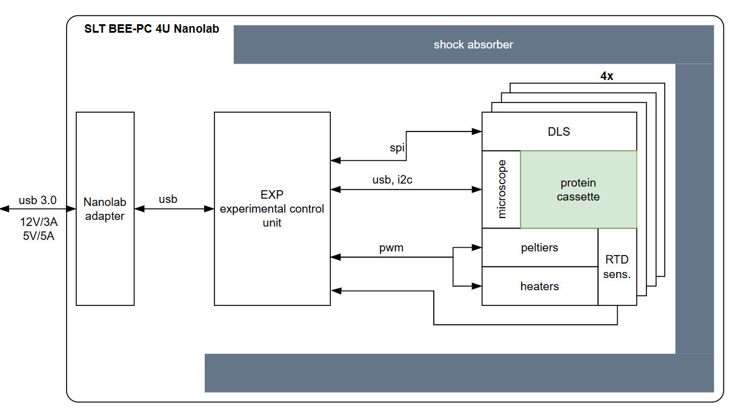

# 

# Requirements

## Interface

BEE-PC 4U will interface with Voyager Tech. Nanode at 2 ports (2U area)

1. Data interface: USB2.0, USB3.0
2. Power interface: 5V(USB)/3A, 5V(AUX)/5A, 12V(AUX)/3A
3. If both ports are used, power lines shall be isolated

## Experiment controllers (EXP)

BEE-PC 4U EXP shall be capable of below functionalities.

1. 10x NTC/RTD temperature readings
2. 8x TEC drivers (max 5V/3A each)
3. 8x film heaters (max 12V/2A each)
4. 4x DLS hardware (photo diode, laser diode), each hardware configuration as below
   1. 32 photodiode (8x4)
   2. 32 laser diode (8x4)
   3. laser diode current control and measurement
   4. photodiode gain control
5. 8x USB2.0 endoscope cameras
   1. multiplexer should be considered to handle cameras one by one
6. 8x LED driver (max 12V/1A or 5V/2A)
7. 2x I2C sensor buses
8. AI-accelerated hardware to assist in space automation